Name: ___________________________________ SOCIAL STUDIES 10
NT CHAPTER 3: GEOGRAPHY OF CANADA

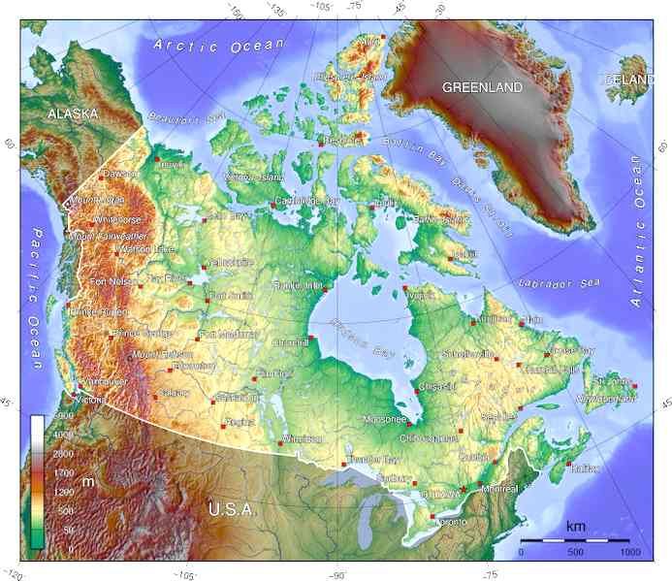

CHAPTER OUTCOMES

- identify and understand the five themes of geography
- identify the different physical and natural regions of Western Canada
- analyze the processes that formed Canada’s regions
- describe the effect of climate and physical geography on population distribution
- describe the formation of cultural landscape
- evaluate the impact of human actions on the environment
- describe the impact of natural and artificial boundaries

Q&As

- Geography is the study of a place and how people interact with the world around them. What subtopics can be included to enable us to have a better understanding of a place?

- Give 3 examples of physical geography.

- Give 3 examples of human geography.
- What are the five organizing principles or themes of geography?

- How is a place’s precise or absolute location measured?

- Give several examples of how a GPS may be used.

- How might Canada’s physical location affect the country’s economy?

- What is meant by cultural landscape?

- Give three examples of how landforms and vegetation change.

- How do you think technology has affected our perception of place?

- What are some characteristics that might identify a region?

- What do you understand by the term “global village” and globalization?

- Why would geographers be interested in cyberspace?

- Maps are a visual representation of an area and can give different types of information. For example, a physical or topographical map gives information about the shape of the land. What other types of maps are there?
- Over millions of years, how did ice and snow shape Canada as we know it today?

- Complete a chart that describes the physical regions of Canada.
- Draw a diagram and explain in your own words how the “Big One” may occur.

- Describe a continental climate.

- Describe a maritime climate.

- Draw a diagram to explain each of the five factors that affect temperature.
- Draw a diagram to explain each of the following: orographic, convectional, and frontal precipitation.
- What two things are measured in a climograph?

- On a separate sheet of paper, answer questions 1, 3, and 4 on page 28.
- What is climate change and what is attributed as its cause?

- Give two examples of how interdependence and balance in an ecosystem can be disrupted.

- Use figure 1-35 on page 29 to answer the following:
What is the largest natural region in Canada?

What is most of British Columbia?

In which provinces can we find parklands and grasslands?

What are the natural regions of the northernmost parts of Canada?

- What is the reason for the exceptionally tall trees in the Pacific Northwest?

- Describe how different types of human activity altered the landscape of the prairie grasslands.

- What are the benefits and risks of the Alberta oil sands?

- Which countries are laying their claim on the Arctic?

Why is there a surging interest in the Arctic?

- How would cultural backgrounds of settlers affect the land?

- Describe some functions of settlement found in the Western Communities.

- What is boom and bust? What does this potentially mean for the resource town?

- Give examples of natural boundaries.

- Give examples of political boundaries.

- Which is Canada’s newest region and why was it created?

- How have aboriginal peoples’ claim to traditional lands changed in the latter part of the 20th century?

My thoughts on
who owns the Arctic:

impact of human activity on the environment:

