Name: _____________________ NT SOCIAL STUDIES 10
CHAPTER 2- THE COLONISTS: LAND AND GOVERNMENT
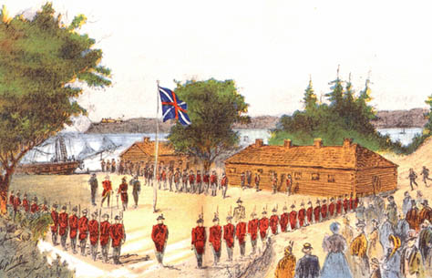

KEY TERMS

Upper Canada Lower Canada colony Loyalist class system aristocracy
Family Compact Chateau Clique Patriote Radical Reformer land speculator
Crown reserves clergy reserves coffin ship steerage Legislative Assembly grievance oligarchy seigneurial system bourgeoisie insurrection
Fils de la Liberté nationalism responsible government representative government

KEY FIGURES

John Molson John Labatt Harriet Tubman Mary Ann Shadd Josiah Henson
John Strachan William Lyon Mackenzie Louis-Joseph Papineau Robert Gourlay
Egerton Ryerson Robert Baldwin Francis Bond Head Lord Durham Wolfred Nelson Susanna Moodie Lord Durham Lord Sydenham

CHAPTER OUTCOMES

- assess the impact of geography on Canada’s early development and colonization
- describe significant events and trends affecting immigration to Canada
- compare the roles and daily activities of men and women in colonial society
- evaluate the influence of immigration on Canadian society and identity
- discuss the causes and consequences of the Rebellions of 1837
- explain the evolution of responsible government in Canada
- describe the factors that contributed to a changing national identity, including the development of Canada as a French and English country

- What were the two main colonies in Eastern Canada in the early 1800s?

- Give examples of activities that brought in immigrants to the colonies in Canada following the War of 1812?

- What is the Royal Proclamation of 1763?

- How were the First Nations affected by European colonization?

- What does the use of terms by Europeans, such as “discovered the Americas” and “giving handouts to Natives” say about their attitude towards Aboriginal peoples and their land?

- What were the two key purposes of the British arrival in North America?

- Who were the original settlers of Upper Canada?

- In point form, describe the physical challenges faced by settlers to Upper Canada.

- List and evaluate contributions made by First Nations in the settlement of European settlers and fur traders.

- How did social class affect the settlements of Upper Canada?

- Explain the four barriers listed below that ordinary colonists in Upper Canada faced in finding land.
a) Family Compact:

b) Crown and Clergy Reserves:

c) Absentee Landlords and Speculators:

d) First Nations People:

- What type of land ownership and farming was used in Lower Canada?

- What were some of the challenges faced by immigrants aboard the coffin ships to Canada.

- What was the ethnic makeup of Canada in 1871?

- What are some of the contributions made by the early black immigrants to Canada?

- Describe some of the roles played by the women of Upper and Lower Canada.

- Why was a good marriage prospect so important for women living at this time?

- What are the two defining characteristics of democratic governments?

- Why did ordinary people want reform in Upper Canada? List some of the grievances.

- Why was voting considered dangerous or difficult in the 1830s?

- Explain the problems of French Canadians in Lower Canada under each title.
a) Economic:

b) Political:

c) Cultural:

- Using the textbook and the resources provided, complete the chart describing the various reform groups.

- What steps did Papineau and the Patriotes take to address reform?

- Why did the rebellion in Lower Canada fail?

- What is a consequence of the failure of the rebellion in Lower Canada?

- Why did MacKenzie and the Radicals take up arms?

- Why did the rebellion in Upper Canada fail?

- How were the leaders of the rebellion punished?

- What was the purpose of Lord Durham’s appointment?

- What were the three recommendations made by Lord Durham?

- Which of Durham’s recommendations was followed immediately?

- Why was Lord Sydenham’s Act of Union unfair to the French Canadians?

questions I have: ?
? ?

