Name: _____________________ NT SOCIAL STUDIES 10
CHAPTER 4: THE NORTHWEST
KEY TERMS 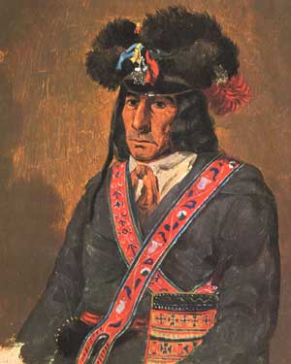
Hudson’s Bay Company (HBC) North West Company (NWC) Rupert’s Land York Factory
Fort William hierarchy hivernants voyageur
portage middleman Métis bison
pemmican country-born seigneurial pattern Red River Selkirk Settlement crofters Pemmican Proclamation
Battle of Seven Oaks merger Red River Resistance free trade provisional government Orange Order Canadian Party

KEY FIGURES

King Charles II Pierre Radisson Médart de Groseilliers Lord Selkirk Miles Macdonell
Duncan Cameron Robert Semple George Simpson John Schultz Louis Riel
John A. Macdonald Thomas Scott

CHAPTER OUTCOMES

- describes contributions made by aboriginal peoples to the development of Canada
- analyze the impact of the fur trade on the First Nations and the Métis
- examine European attitudes towards Native peoples and the Métis
- assess the role of First Nations and Métis women in the fur trade
- discuss the creation of the Red River settlement
- evaluate the interactions between Aboriginal peoples and stakeholders in the fur trade
- assess factors that led to the expansion of Canada, including the purchase of Rupert’s Land
- analyze key events and the consequences of the Red River Resistance

Q&As

- Briefly describe how the HBC was founded.

- Complete the comparison chart of the HBC and NWC.
- What are some of the challenges faced by early European fur traders?

- Who is David Thompson and how has he contributed to the establishment of Canada ?

- What roles did the native peoples play in the establishment of the fur trade?

- Identify both the positive and negative impacts of the fur trade on the native peoples.

- How might the fur trade bring an increased level of conflict among various First Nations tribes?

- Who are the Métis? How are they “children of the fur trade?”

- Explain why the bison hunt was so important to the Métis.

- Why are the rules of the bison hunt so strict?

- Describe how and why the Selkirk Settlement was created.

- How did the Selkirk settlement impact the Métis?

- How were the Métis viewed by many of the Selkirk settlers?

- Who is Cuthbert Grant?

- Read pg. 150-151. Why did NWC and the Métis see the Pemmican Proclamation as a threat?

- What happened in the Battle of Seven Oaks?

- What happened to Lord Selkirk after the Battle of Seven Oaks?

- Discuss the conditions of the merger between the HBC and NWC.

Who do you think came out on top? Why?

- How did George Simpson maintain control of the HBC operations?

- How did the Métis maintain their self sufficiency in Red River between 1821 and 1860?

- What was John Schultz’s attitude toward the Métis?

- Explain the conditions under which Canada purchased Rupert’s Land.

- Why did the Métis object to the arrival of the surveyors and land speculators?

- Explain why Riel formed a provisional government.

Are his actions legitimate?
- What was the purpose of the Métis List of Rights?

- How is it similar to the Charter of Rights and Freedoms? How is it different?

- Why was Thomas Scott executed?

- How did John Schultz and the Orange Order use the execution of Scott to advance their cause?

- What were some of the terms under which Manitoba agreed to confederate?

- Describe what happened to Riel following Manitoba’s admission to Confederation.

