Name: _____________________ NT SOCIAL STUDIES 10
CHAPTER 5: CHANGE COMES TO THE PRAIRIES
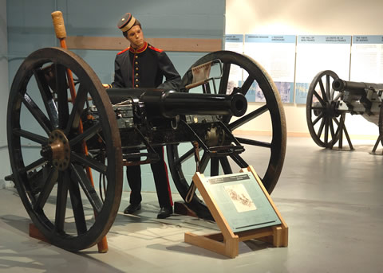
KEY TERMS
Manitoba Act homesteader scrip land speculator whiskey trader
NWMP treaties firewater Pacific Scandal National Policy
tariffs CPR CPR Syndicate Metis Bill of Rights Laws of St. Laurent
Indian Act Department of Indian Affairs treason Northwest Uprising

KEY PLACES
Fort Carleton Cypress Hills Fort Whoop-Up Duck Lake Batoche
Kicking Horse Pass Regina

KEY FIGURES
John A. Macdonald Lawrence Clarke Gabriel Dumont Hugh Allan
Georges E. Cartier Alexander Mackenzie Donald Smith George Stephen
James Hill William Van Horne Lief Crozier Chief Crowfoot

CHAPTER OUTCOMES

- describe contributions made by Aboriginal peoples to the development of Canada
- evaluate the rationale for the numbered treaties and their impact on First Nations and the Métis
- identify causes and key events of the Northwest Uprising
- describe the events surrounding the construction of the CPR and analyze its importance to the development of the Canadian West
- assess factors that led to the expansion of Canada, including the national railway and confederation

Q&As

- The Manitoba Act created the province of Manitoba as part of the Dominion of Canada. What 3 things are part of the Act?

- How did this signal hope for the Métis?

- Why were Canadian troops in Red River? How effective were they in performing their job?

- What is the value of a scrip and what problems did the Métis face with regards to the scrip?

- How did land speculator’s make money off the Métis?

- Why did so many Metis leave Red River in the wake of the Manitoba Act?

Where did they go?

- What was the purpose of “The Laws of St. Laurent”?

- What are the three sources of income for the Métis at this time?

- How and why did Lawrence Clarke make it did difficult for the Métis to maintain a standard of living?

- In the account “The Hunt of 1875” what is the position taken by the Métis under Gabriel Dumont?

What position is taken by Lawrence Clarke and his men?

- List 3 things that happened to the Metis as a result of the “Laws of St. Laurent” being negated.

What happened to the bison?

- Who are the whiskey traders, and what did they do to the Natives?

- How did Ottawa respond to the whiskey traders?

- In your opinion, was Ottawa really interested in protecting the Natives? Why or why not?

- How many treaties were signed between 1871 and 1877 and why did the Natives sign treaties with the
Canadian government?

- What did the government promise the Indians when they signed the treaties?

Were the promises kept? Why or why not?

- What is significant about Treaty No. 6?

- Are the rights that First Nations people have today (right to resources, health care, education, etc.) as part of the treaty processes of the past? Why or why not?

- Why did the First Nations fail as farmers?

- What is the Indian Act and what are some of its consequences?

- What happened as a result of the native population being exposed to European missionaries?

- What did the Métis petitions express?

- What would the Canadian government gain from the lands in the Northwest?

- Why was Louis Riel called back to the Northwest?

- How is the Métis Bill of Rights similar to the U.S. Declaration of Independence?

- How did John A. Macdonald use the crisis involving the Métis to his advantage?

What role did Lawrence Clarke play in this?

- What prompted Riel to take up arms against the Canadian government?

- Describe the key battles of the Northwest Rebellion of 1885.

- How did different Indian leaders respond to the crisis?

- Why do you think Louis Riel gave himself up to the government?

- What was the charge, verdict and sentence for Louis Riel?

Do you agree or disagree? Why or why not?

- What were the consequences of the Uprising for many First Nations and Métis?

- What was John A. Macdonald’s dream for Canada and how did he plan on
achieving it?

- Explain what happened in the Pacific Scandal.

What was its consequence?

- Why did B.C. threaten secession?

- Explain each of the three points of Macdonald’s National Policy.

- What benefits were promised to the CPR Syndicate?

- Why was WilliamVan Horne hired and how successful was he?

- What were the major challenges in the construction of the railway?

- How did Macdonald get Parliament to fund the completion of the CPR through
the Northwest?

- Who is Edward Mallandaine?

